SURREY COUNTY NETBALL ASSOCIATION

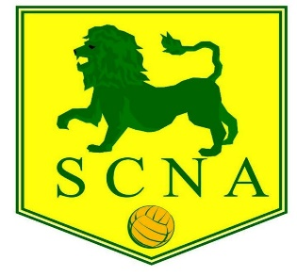

THE 90th ANNUAL GENERAL MEETING OF THE SURREY COUNTY NETBALL ASSOCIATION WILL BE HELD ON WEDNESDAY 7th JUNE 2022 AT PURLEY SPORTS CLUB at 7.30pm for refreshments and start of meeting at 8pm

AGENDA

- President’s Welcome Opening Address
- Apologies for Absence
- Minutes of the Previous Annual General Meeting 8 June 2022 at Purley Sports Club
- Matters Arising
- Reports from Executive Committee, Schools Section, Leagues including Junior leagues, NDO
- Presentation of Accounts for 2022/2023
- Membership fees for the season 2023/24
- Election of President, Vice President, and Officers (Chairman, Vice Chairman, Hon Secretary, Hon Treasurer, Membership Secretary/Asst Treasurer, County Officiating Lead, Assistant County Officiating Lead, Umpiring Mentoring Manager, Coaching Secretary, Communications/Publicity Secretary, County Safeguarding Officer, Regional Competition representative, Minuting Secretary, Schools Representative, County Performance Pathway Lead, Junior League Representative, Volunteer Officer, Diversity/Equalities Officer, County Resolution Lead)
- County League Presentation to winning club; and any proposed Rules change
- Surrey Lions awards presentations
- Any Other Business

Nominations for President, Vice President and Officers, and matters for ‘Any Other Business’ should be sent to Jackie Rowland at jbr51@hotmail.co.uk by FRIDAY 2nd June 2023.

ck/jbr
5th April 2023

